DEVELOPMENT OF A WEB BASED SIWES ATTENDANCE TRACKING SYSTEM
BY
JOSHUA BAKO KUVALA
FCP/CCS/20/1009

A PROJECT SUBMITTED TO THE DEPARTMENT OF CYBER SECURITY, FEDERAL UNIVERSITY DUTSE, IN PARTIAL FULFILMENT OF THE REQUIREMENTS FOR THE AWARD OF THE DEGREE OF BACHELOR OF SCIENCE (B.Sc. Hons.) IN CYBER SECURITY.

OCTOBER, 2025

CERTIFICATION

This project entitled 'Development of a Web Based SIWES Attendance Tracking System' by Joshua Bako Kuvala (Reg No: FCP/CCS/20/1009) meets the requirements governing the award of the degree of Bachelor of Science in Cyber Security and is approved for its contribution to knowledge and literary presentation.
___________________________ ___________________________
Mr. Hassan Abdullahi BKD Date
Supervisor
___________________________ ___________________________
Dr. Farouk Lawan Gambo Date
Head of Department
___________________________ ___________________________
External Examiner Date

DEDICATION
This project is lovingly dedicated to the memory of my late father, Mr. Kuvala Bako Ahmadu, whose life continues to inspire me. Your strength, discipline, and quiet wisdom shaped the very foundation of who I am today. Though you are no longer here, your spirit remains my guiding light in every path I take.
To my beloved mother, Mrs. Indo Pajo Bako, CNA, your unwavering love, sacrifices, and prayers have been the pillars of my growth. You have been my greatest motivation, my first teacher, and my endless source of encouragement. I owe every step of this journey to your selfless devotion and unshakable faith in me.
And to my beloved adopted father, Dr Bulus Dan Habu whose guidance and support have been my pillar, thank you for believing in me even when I doubted myself. Your mentorship and care have filled the void and strengthened my resolve to strive for excellence.

ACKNOWLEDGEMENT
First and foremost, I give all glory, honor, and praise to God Almighty, the source of wisdom, strength, and inspiration throughout this journey. His grace has been my anchor through every challenge and His mercy my constant help in times of need. Without Him, this achievement would not have been possible.
My deepest appreciation goes to my supervisor, Mr. Hassan Abdullahi (BKD), for his guidance, patience, and invaluable support throughout the course of this project. His mentorship, constructive criticism, and encouragement greatly shaped this research and brought it to completion.
I also wish to extend my sincere gratitude to all the lecturers in the Department of Cyber Security, Federal University Dutse, for their dedication, knowledge, and commitment to nurturing students like me. Each of you has played a vital role in my academic and personal growth.

To my colleagues, friends, and everyone who supported me in one way or another, I say thank you. Your words of encouragement, assistance, and friendship have made this journey a memorable one.
Above all, I remain thankful for the opportunity to learn, grow, and contribute to knowledge through this project.

TABLE OF CONTENTS
CERTIFICATION............................................................................. ...i
DEDICATION................................................................................ ii
ACKNOWLEDGEMENTS.......................................................................... iii
ABSTRACT.................................................................................. iv
CHAPTER ONE: INTRODUCTION................................................................. 1
1.1 Background of the Study............................................................... 1
1.2 Statement of the Problem.............................................................. 2
1.3 Aim and Objectives of the Study....................................................... 3
1.4 Scope and Limitations of the Study.................................................... 3
1.5 Significance of the Study............................................................. 4
1.6 Organization of the Study............................................................. 4
CHAPTER TWO: LITERATURE REVIEW............................................................ 5
2.1 Introduction.......................................................................... 5
2.2 Conceptual Framework.................................................................. 5
2.3 Review of Related Studies............................................................. 6
2.4 Review of Existing Attendance Systems................................................. 7
2.4.1 Manual Attendance Systems........................................................... 7
2.4.2 Biometric Attendance Systems........................................................ 7
2.4.3 Web Based Attendance Systems........................................................ 8
2.5 Comparative Analysis of Existing Systems.............................................. 8
2.6 Technologies Used in Web Based Systems................................................ 9
2.6.1 HTML, CSS, and JavaScript........................................................... 9
2.6.2 Node.js............................................................................. 9
2.6.3 Supabase Database................................................................... 10
2.6.4 IP Geolocation API (ipapi.co)....................................................... 10
2.7 Summary of Literature Review.......................................................... 11
CHAPTER THREE: METHODOLOGY AND TOOLS/DATA PRESENTATION................................2
3.1 Introduction.......................................................................... 12
3.2 System Design Methodology............................................................. 12
3.3 System Architecture................................................................... 13
3.4 System Requirements................................................................... 14
3.4.1 Hardware Requirements............................................................... 14
3.4.2 Software Requirements............................................................... 14
3.5 System Implementation................................................................. 15
3.6 Data Presentation and Flow............................................................ 16
3.7 Summary............................................................................... 17
CHAPTER FOUR: ANALYSIS AND DISCUSSION OF RESULTS.......................................... 18
4.1 Introduction.......................................................................... 18
4.2 System Analysis....................................................................... 18
4.3 System Testing........................................................................ 19
4.3.1 Unit Testing........................................................................ 19
4.3.2 Integration Testing................................................................. 20
4.3.3 System Testing...................................................................... 20
4.3.4 User Acceptance Testing (UAT)....................................................... 21
4.4 Results and Discussion................................................................ 21
4.5 System Screenshots.................................................................... 22
4.6 Strengths and Limitations of the System............................................... 23
4.7 Summary............................................................................... 24
CHAPTER FIVE: SUMMARY, CONCLUSION AND RECOMMENDATION...................................... 25
5.1 Summary............................................................................... 25
5.2 Conclusion............................................................................ 26
5.3 Recommendations....................................................................... 27
5.4 Contribution to Knowledge............................................................. 28
5.5 Suggestions for Further Research...................................................... 29
5.6 Summary............................................................................... 29
REFERENCES................................................................................ 30
APPENDICES................................................................................ 32
Appendix A: System Design Diagrams........................................................ 32
Appendix B: Sample Interface Screenshots.................................................. 33
Appendix C: Source Code Snippet........................................................... 34
Appendix D: System Testing Summary........................................................ 35
Appendix E: User Manual (Brief Guide)..................................................... 36

ABSTRACT

The Student Industrial Work Experience Scheme (SIWES) plays a vital role in equipping Nigerian students with practical industry skills related to their field of study. However, the process of recording and verifying student attendance during the SIWES period has been largely manual, error prone, and susceptible to falsification. This project focuses on the development of a web‑based SIWES attendance tracking system designed to automate attendance recording, improve monitoring, and enhance transparency between students and supervisors. The system was developed using HTML, CSS, and JavaScript for the frontend, Node.js for backend logic, Supabase for database management, and IP Geolocation API (ipapi.co) for verifying students’ location during attendance marking. The system provides a real‑time attendance monitoring dashboard for supervisors, reduces paperwork, and minimizes data loss. The developed system enhances accountability, efficiency, and trustworthiness in the SIWES management process.

CHAPTER ONE

INTRODUCTION

Background of the Study
The Student Industrial Work Experience Scheme (SIWES) was established to bridge the gap between academic knowledge and practical experience. It allows students to apply theoretical knowledge acquired in classrooms to real life industrial settings, thereby preparing them for future careers. Despite its importance, monitoring and verifying student participation during SIWES remains a major challenge in many Nigerian institutions. Manual attendance registers are prone to manipulation, loss, and errors, leading to inaccurate records and poor supervision. The evolution of digital technology and web based systems offers opportunities to improve this process. A web based attendance tracking system provides an automated and centralized platform where students can log their daily attendance, and supervisors can monitor, verify, and generate reports seamlessly. Such a system ensures authenticity, data security, and accessibility, enabling supervisors to verify attendance through IP based geolocation data. By leveraging Node.js for backend operations, Supabase for secure cloud data storage, and IP Geolocation API (ipapi.co) for location validation, this system aims to simplify the SIWES attendance process, enhance accountability, and promote integrity in industrial training supervision.

1.2 Problem Statement
The current method of managing SIWES attendance in most Nigerian universities relies heavily on manual registers and physical documentation like the log books. This approach leads to inefficiency, errors, and sometimes intentional falsification of attendance records by students. Supervisors face difficulties verifying whether students were physically present at their training locations. In addition, log books attendance sheets are vulnerable to damage or loss, making record retrieval tedious and unreliable. These challenges necessitate the development of an automated, reliable, and verifiable system that tracks student attendance in real time, ensures transparency, and allows supervisors to monitor students remotely.

1.3 Aim and Objectives
The aim of this project is to develop a web based system that automates and secures SIWES attendance tracking for students and supervisors.
The specific objectives of the study include:
• To design a responsive web interface for student attendance logging and supervisor monitoring.
• To implement a Node.js backend integrated with Supabase for data storage and retrieval.
• To incorporate IP based geolocation using ipapi.co for verifying student attendance locations.
• To enable supervisors to generate real time attendance reports and monitor participation remotely.
• To ensure data integrity, accessibility, and scalability through cloud‑based deployment.

1.4 Research Questions
This research is guided by the following questions:
• How can web based technologies improve the accuracy and reliability of SIWES attendance tracking?
• In what ways can geolocation verification enhance supervision and transparency?
• What advantages does cloud‑based storage (Supabase) offer in securing attendance data?
• How can automation reduce errors and time spent on manual attendance verification?

1.5 Scope and Limitations
This project focuses on developing a web based attendance system for SIWES students. It covers features such as student registration, attendance logging, geolocation verification, and report generation. The system is intended for use by students, supervisors, and SIWES coordinators of Federal University Dutse. However, it does not include mobile applications or biometric verification at this stage. The system also depends on internet connectivity and accurate IP data for location tracking.

1.6 Significance of the Study
This project contributes significantly to the improvement of SIWES record management by introducing automation, transparency, and reliability. It minimizes falsification of attendance records, enhances supervision efficiency, and ensures that all attendance information is securely stored in the cloud. Furthermore, it provides a foundation for future advancements in student monitoring systems and promotes accountability in the SIWES program.

CHAPTER TWO

LITERATURE REVIEW

2.1 Introduction
This chapter presents a detailed review of existing studies, systems, and technologies relevant to attendance tracking and management. It explores various methods adopted in academic and industrial settings for monitoring attendance, their limitations, and how modern web technologies have been used to address these challenges. The goal of this review is to identify the gaps in current systems and establish the foundation upon which the proposed SIWES attendance tracking system is built.

2.2 Conceptual Framework
The conceptual framework for this research is centered on automating the Student Industrial Work Experience Scheme (SIWES) attendance process. The system is designed to provide a digital solution where students can record their daily attendance online, and supervisors can monitor and verify attendance remotely.
Three main actors form the core of this framework students, supervisors, and administrators. Students are responsible for marking their attendance daily through the web interface. Supervisors validate the attendance records, while administrators manage overall data storage, report generation, and system updates.
To ensure transparency and authenticity, the system integrates IP based geolocation technology that confirms the student’s location at the time of attendance marking. This combination of automation, real-time verification, and cloud-based data management enhances efficiency, accuracy, and accountability throughout the SIWES process.

2.3 Review of Related Studies
Over the years, different attendance monitoring systems have been developed to improve accuracy and reliability. Early systems were manual, using paper registers to document attendance. These methods were simple but prone to errors, loss of records, and manipulation.
As technology evolved, institutions began using digital solutions such as biometric and electronic card systems. Biometric systems, for example, use unique identifiers like fingerprints or facial recognition to record attendance. Although accurate, these systems require specialized hardware, high installation costs, and constant maintenance. They are also not feasible for programs like SIWES, where students are stationed in multiple locations.
Recent studies have emphasized web-based attendance systems, which use online platforms to collect and store data. These systems allow students and supervisors to interact remotely through internet-enabled devices. They are more flexible, cost-effective, and accessible compared to traditional approaches. Cloud integration also ensures data safety, easy retrieval, and scalability.
Despite these advancements, many existing web-based systems lack verification mechanisms to confirm the physical presence of users. The proposed SIWES attendance system addresses this by incorporating IP geolocation verification to ensure authenticity.

2.4 Review of Existing Attendance Systems
- Manual Attendance Systems
Manual attendance systems rely on paper registers where students manually sign their names daily. While this method is inexpensive and easy to implement, it is highly unreliable. It is vulnerable to falsification, misplaced records, and delays in supervision. For SIWES programs, manual attendance creates difficulty in monitoring students posted across various organizations.

- Biometric Attendance Systems
Biometric systems record attendance using physiological traits such as fingerprints or facial recognition. They offer improved accuracy and prevent impersonation. However, they are expensive to deploy and maintain, especially for programs spread across different locations. Additionally, the requirement for hardware devices makes them impractical for use in remote or off-site situations.

- Web Based Attendance Systems
Web based systems automate attendance recording using internet technology. Students log in through a web interface to mark attendance, while supervisors monitor and verify entries remotely. The records are stored in a cloud database for easy access and reporting. When integrated with technologies like IP geolocation, these systems can confirm user location, thus preventing false attendance claims. Web-based systems are scalable, secure, and cost-effective, making them ideal for SIWES tracking.

2.5 Comparative Analysis of Existing Systems
Each type of attendance system offers specific benefits and faces particular limitations. Manual systems are simple but unreliable, biometric systems are accurate but costly, and web-based systems provide an effective balance between functionality and affordability.
The proposed SIWES attendance tracking system adopts the web-based approach enhanced with IP geolocation. This method combines accessibility with authenticity by confirming students’ physical locations when they mark attendance. It overcomes the weaknesses of existing systems by offering a flexible, reliable, and transparent solution.

2.6 Technologies Used in Web Based Systems
HTML, CSS, and JavaScript
These technologies are essential for creating the web interface of the system. HTML defines the structure of the pages, CSS ensures proper design and responsiveness, while JavaScript adds interactivity, allowing users to perform tasks such as submitting forms and viewing updates dynamically.

Node.js
Node.js is used for backend development. It manages communication between the client interface and the database. Its asynchronous processing model ensures fast and efficient handling of requests, making it suitable for real-time applications like attendance tracking.

Supabase Database
Supabase is an open source backend platform built on PostgreSQL. It provides authentication, data storage, and secure communication between the server and client. In this project, Supabase is responsible for storing student records, attendance logs, and supervisor reports securely in the cloud.

IP Geolocation API (ipapi.co)
This API identifies a user’s location based on their IP address. It ensures that students can only mark attendance from their assigned SIWES locations. The feature enhances transparency, eliminates falsification, and builds trust in the attendance management process.

2.7 Summary of Literature Review

This chapter reviewed different attendance systems and the technologies used in automating attendance tracking. It highlighted the shortcomings of manual and biometric methods and emphasized the potential of web-based systems in promoting accuracy, flexibility, and accountability. The proposed system, built on web and geolocation technologies, bridges existing gaps by providing a verifiable and efficient solution for SIWES attendance management.

CHAPTER THREE

METHODOLOGY AND TOOLS/DATA PRESENTATION

3.1 Introduction
This chapter outlines the methodology and tools used to design and implement the SIWES attendance tracking system. It discusses the research approach, system architecture, software and hardware requirements, and data flow within the system. Each phase of development is explained in detail, from conceptualization to deployment.

3.2 System Design Methodology
The system was developed using a hybrid methodology that combines elements of the waterfall and agile models. The waterfall model provided a structured sequence for requirement analysis, design, implementation, and testing, while agile principles allowed flexibility to make improvements during development. The major stages include:

1. System Analysis – Understanding the problem and defining system requirements.
2. System Design – Creating the architecture and interface of the system.
3. Implementation – Translating design into working code.
4. Testing and Evaluation – Verifying that the system performs as expected.

This combination ensured a balance between organization and adaptability throughout the project.

3.3 System Architecture
The architecture of the system follows a three tier client server model, which consists of the presentation, logic, and data layers.

Presentation Layer (Frontend): This layer, built with HTML, CSS, and JavaScript, serves as the user interface where students and supervisors interact with the system. It ensures simplicity and responsiveness.
Logic Layer (Backend): Powered by Node.js, this layer handles user authentication, attendance processing, and database communication.
Data Layer: Managed by Supabase, this layer stores attendance data, student records, and supervisor reports. The IP Geolocation API integrates with this layer to verify user location before submission. This structure ensures data accuracy, system scalability, and reliable communication between all components.

3.4 System Requirements

Hardware Requirements
* Laptop or smartphone with internet connectivity.
* Minimum of 2GB RAM and 1.6GHz processor speed.
* Modern web browser (Chrome, Firefox, or Edge).

Software Requirements
* Node.js runtime environment for backend processing.
* Supabase database account for data storage.
* API key from ipapi.co for geolocation functionality.
* Visual Studio Code or any preferred text editor for development.

3.5 System Implementation
The implementation phase involved converting the design into a functional system. The frontend was developed using HTML, CSS, and JavaScript to create a user friendly interface. Node.js managed server-side operations and linked the system to the Supabase database. The IP Geolocation API from ipapi.co was integrated to verify user location when marking attendance.
Throughout development, continuous testing and debugging were performed to ensure performance, security, and data accuracy. Each module student, supervisor, and administrator was tested to confirm that all functionalities worked as intended.

3.6 Data Presentation and Flow
The data flow within the system begins when a student logs into the platform and marks attendance. The system automatically records the timestamp, user ID, and IP location. The Node.js backend processes this information and stores it securely in the Supabase database. Supervisors can then access real-time attendance reports through their dashboard.
This seamless data flow ensures consistency, eliminates duplication, and enhances the reliability of the records stored within the system.

3.7 Summary
This chapter described the methodology and tools used in developing the SIWES attendance tracking system. It explained the design approach, architecture, and technology stack that supports the system. The next chapter focuses on the analysis, testing, and discussion of the system’s performance and results.

CHAPTER FOUR

ANALYSIS AND DISCUSSION OF RESULTS

4.1 Introduction
This chapter presents the analysis, testing, and evaluation of the web-based SIWES attendance tracking system. It describes how the system was implemented, tested, and analyzed to ensure that it meets the stated objectives. It also discusses the results obtained, the system’s functionality, and how it addresses the challenges identified in traditional attendance monitoring methods.

4.2 System Analysis
System analysis was carried out to identify the functional requirements of the proposed system and to evaluate how these requirements could be met using modern web technologies. The analysis covered user needs, data flow, and operational structure.
The major actors in the system include:

Students: Responsible for marking their daily attendance through the online interface.
Supervisors: Review and validate the attendance records submitted by students.
Administrators: Oversee user registration, manage records, and generate reports.

Each actor interacts with the system through specific modules that handle authentication, attendance submission, and verification. The analysis revealed that automation, remote access, and real-time data updates were essential to overcoming the limitations of manual attendance tracking.

4.3 System Testing
Testing was conducted to ensure that all system components functioned correctly and that the objectives were achieved. The following testing methods were used:

a. Unit Testing
Each module including the login, attendance marking, and supervisor verification modules was tested individually. The purpose was to identify and fix logical errors during the development process.

b. Integration Testing
After unit testing, the modules were combined and tested together to verify that data flow between them was seamless. The connection between the frontend (HTML, CSS, JavaScript) and backend (Node.js and Supabase) was tested to ensure stability.

c. System Testing
The complete system was tested to confirm that it performs all required functions, including user authentication, attendance submission, and location verification using the IP Geolocation API.

d. User Acceptance Testing (UAT)
Finally, the system was tested by a small group of SIWES students and supervisors. Feedback was collected regarding usability, accuracy, and interface design. Most users found the system easy to use, responsive, and reliable.

4.4 Results and Discussion
The testing and analysis confirmed that the system performed its intended functions effectively. The following were the major results obtained:

1. Efficient Attendance Recording: Students could easily log in and mark attendance online from any internet enabled device.
2. Real Time Location Verification: The system accurately identified the user’s location through the IP Geolocation API, ensuring attendance authenticity.
3. Automated Reporting: Supervisors and administrators could generate attendance reports without manual calculations.
4. Error Reduction: Automation significantly reduced errors caused by manual recordkeeping.
5. Remote Accessibility:The system allowed monitoring and management of attendance records from any location.

Compared to traditional systems, the developed solution offered improved transparency and reduced administrative workload. Supervisors could now confirm student presence without physical visits, and data storage in the cloud guaranteed record safety and easy retrieval.

4.5 System Screenshots
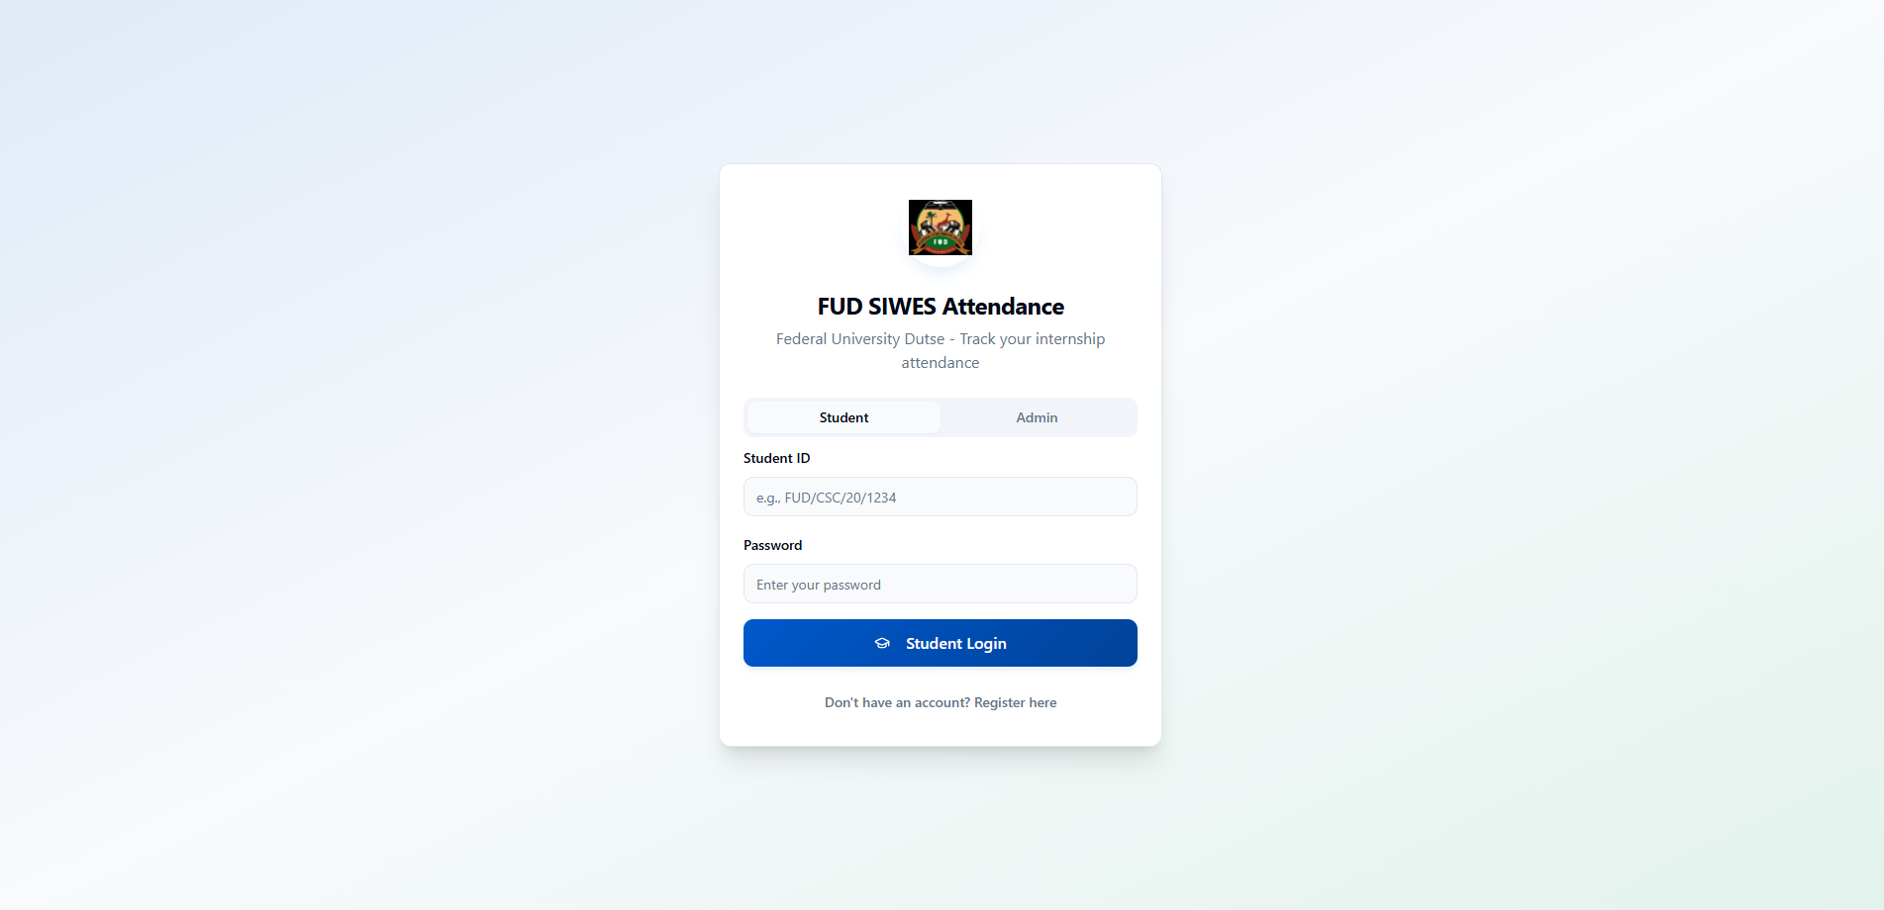

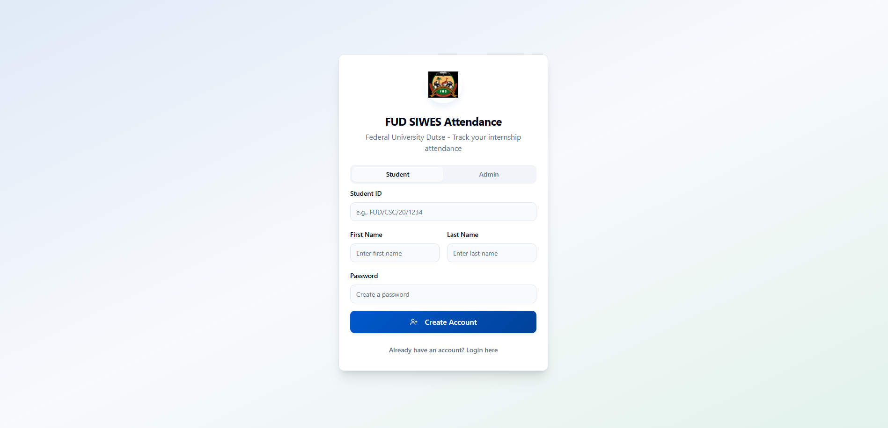
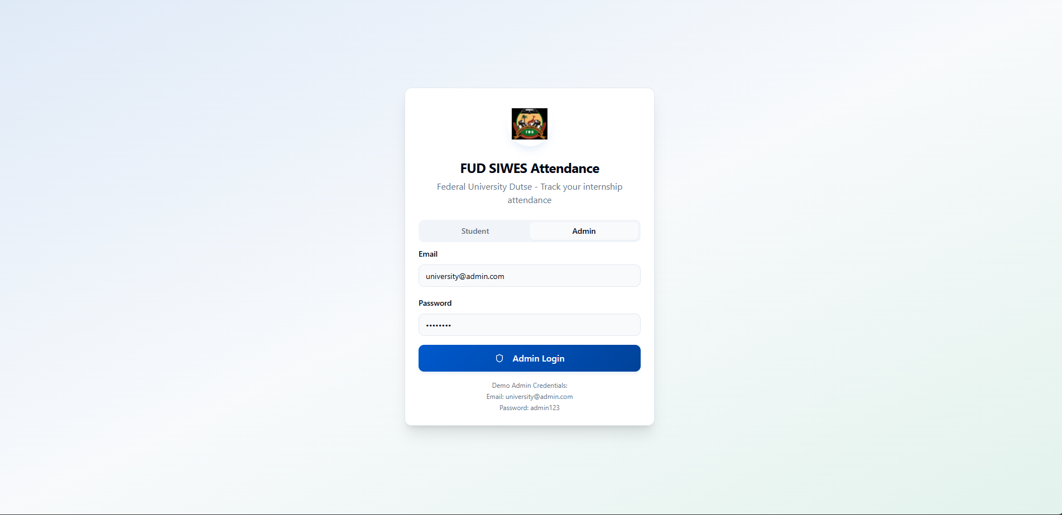

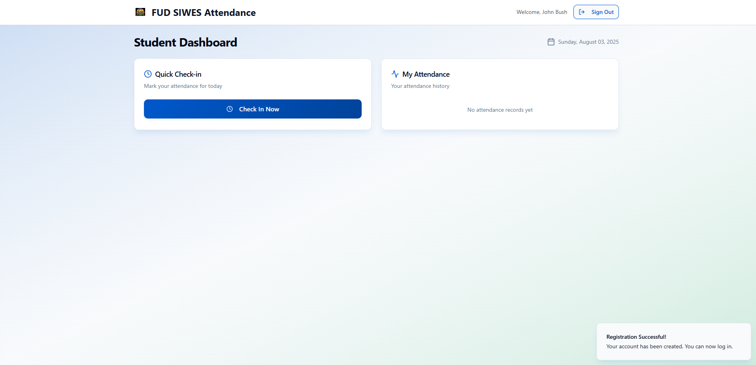

4.6 Strengths and Limitations of the System
Strengths:
* Simplifies attendance tracking for SIWES students and supervisors.
* Integrates IP based verification to prevent false entries.
* Reduces paper usage and promotes digital recordkeeping.
* Cloud storage ensures data integrity and accessibility.

Limitations:
* The system depends on internet availability; users without stable connections may face difficulty.
* Location detection accuracy may vary slightly depending on the user’s network provider.
* Users must have basic digital literacy to interact with the web interface effectively.

4.7 Summary

This chapter discussed the implementation, testing, and evaluation of the SIWES attendance tracking system. The results showed that the system successfully achieved its objectives by providing a reliable, location-verified, and automated platform for attendance management. The next chapter concludes the study and provides recommendations for future improvements.

CHAPTER FIVE

SUMMARY, CONCLUSION, AND RECOMMENDATION

5.1 Summary
This project focused on the design and development of a Web-Based SIWES Attendance Tracking System to address the inefficiencies in manual attendance recording. The system was developed using HTML, CSS, and JavaScript for the frontend, Node.js for backend operations, and Supabase for database management. The IP Geolocation API (ipapi.co) was integrated to verify the location of students when marking attendance.
The project followed a structured methodology that included system analysis, design, implementation, and testing. The developed system allows students to log attendance online, supervisors to validate records remotely, and administrators to manage and generate attendance reports efficiently. The result is a modern, scalable, and user-friendly system that enhances supervision and ensures accountability throughout the SIWES program.

5.2 Conclusion
The web based SIWES attendance tracking system successfully demonstrated how web technologies can improve the accuracy and reliability of attendance monitoring. The system addressed the major challenges of manual methods such as falsification, data loss, and supervision difficulties by introducing automation, real-time location verification, and cloud storage.
The use of IP-based geolocation added a layer of integrity to the process, ensuring that students can only mark attendance from their designated workplaces. With its simple interface and responsive design, the system is suitable for both desktop and mobile users. Overall, the project achieved its objective of developing a reliable and transparent platform for managing SIWES attendance digitally.

5.3 Recommendations
Based on the findings and limitations observed during this project, the following recommendations are made:

1. Integration with Institutional Portals: The system can be linked directly to the university’s official portal to synchronize student data and attendance records automatically.
2. Mobile Application Development: A dedicated mobile app version should be developed to make attendance marking more convenient for users with smartphones.
3. Enhanced Security Features: Future versions can integrate biometric verification or two-factor authentication to strengthen identity confirmation.
4. Offline Functionality: Adding limited offline support will help users in areas with unstable internet connections.
5. Periodic System Updates: Regular updates and maintenance should be carried out to improve performance, compatibility, and user experience.

5.4 Contribution to Knowledge
This project contributes to knowledge by providing a practical and scalable solution for managing SIWES attendance digitally. It demonstrates how web-based and geolocation technologies can be combined to create a transparent and reliable attendance management system. The approach can also be adapted for other academic and organizational attendance systems.

5.5 Suggestions for Further Research
Future researchers may explore integrating AI driven analytics to predict attendance patterns, detect anomalies, and generate insights for better supervision. Additionally, combining the system with biometric verification could further enhance its security and dependability.

5.6 Summary
This chapter summarized the project, highlighted its achievements, and proposed improvements for future research. The web-based SIWES attendance system has proven effective in addressing long-standing challenges in attendance tracking. With continued development, it can serve as a standard model for academic and industrial training programs.

REFERENCES
Adamu, M. A., & Yusuf, K. M. (2021). Implementation of an Online Attendance Management System Using Web Technologies. International Journal of Computer Applications, 183(25), 34–39.

Afolabi, O. A., & Bello, I. O. (2020). Evaluation of Student Industrial Work Experience Scheme in Nigerian Universities: Challenges and Prospects. Journal of Educational Technology and Development, 8(2), 41–52.

Alhassan, B., & Musa, A. (2022). Improving Student Attendance Monitoring Through IP Geolocation Tracking. Journal of Web and Mobile Technology, 10(1), 27–33.

Eze, C. J., & Adeyemi, J. T. (2019). Comparative Analysis of Manual and Automated Attendance Systems in Academic Institutions, Nigerian Journal of ICT Research, 7(1), 15–24.

Ismail, N. M., & Kareem, S. A. (2020). Adoption of Web Based Systems in Higher Education Institutions: Benefits and Barriers. African Journal of Information Systems, 12(3), 112–126.

Johnson, T. K., & Onu, J. P. (2021). The Role of Web Based Applications in Enhancing Administrative Efficiency. Journal of Computing and Applied Research, 9(4), 19–25.

Oladipo, R. O., & Okafor, P. C. (2022). Cloud Based Data Management for Academic Institutions. International Journal of Science and Digital Technology, 11(3), 101–109.

Singh, A., & Patel, D. (2023). A Review on Real Time Web Based Monitoring Systems Using Node.js and Cloud Databases. Global Journal of Engineering and Computer Science, 15(2), 56–63.

Supabase. (2023). Supabase: The Open Source Firebase Alternative. Retrieved from [https://supabase.com](https://supabase.com)

ipapi.co. (2023). IP Geolocation API Documentation. Retrieved from [https://ipapi.co](https://ipapi.co)

APPENDICES

Appendix A: System Design Diagrams

A.1 Use Case Diagram
Illustrates how students, supervisors, and administrators interact with the system.
* Students: Log attendance, view records.
* Supervisors: Verify attendance, monitor reports.
* Administrators: Manage users, generate summaries.

A.2 System Architecture Diagram

Shows the flow of data among frontend (HTML/CSS/JS), backend (Node.js), and database (Supabase), integrated with IP Geolocation API.

A.3 Data Flow Diagram (DFD)

Represents the process of recording, storing, and validating attendance through the system.

Appendix B: Sample Interface Screenshots

Figure B1: Student Login Page

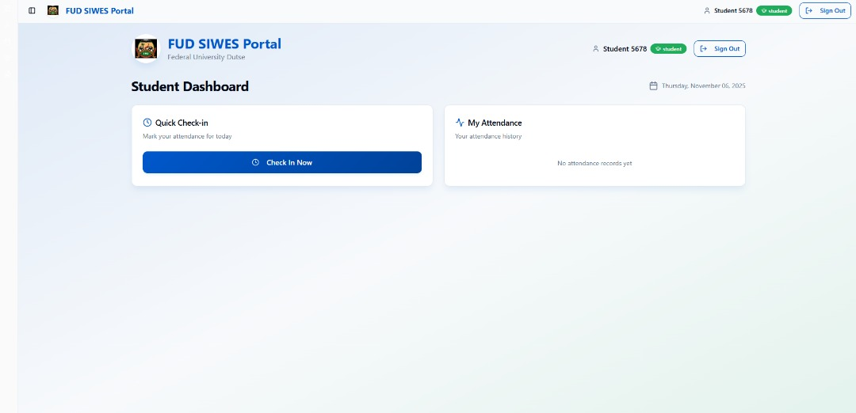

Figure B2: Admin Control Panel
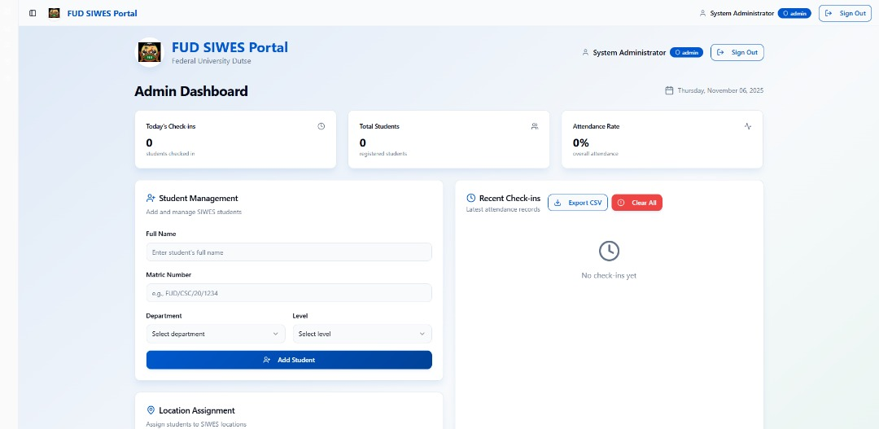

Appendix C: Sample Source Code Snippet

-- Location-Based Attendance Tracking System for SIWES
-- Database Schema

CREATE DATABASE IF NOT EXISTS siwes_attendance;
USE siwes_attendance;

-- Students table
CREATE TABLE IF NOT EXISTS students (
id INT PRIMARY KEY AUTO_INCREMENT,
name VARCHAR(255) NOT NULL,
email VARCHAR(255) UNIQUE NOT NULL,
password_hash VARCHAR(255) NOT NULL,
siwes_location_id INT,
created_at TIMESTAMP DEFAULT CURRENT_TIMESTAMP,
updated_at TIMESTAMP DEFAULT CURRENT_TIMESTAMP ON UPDATE CURRENT_TIMESTAMP,
FOREIGN KEY (siwes_location_id) REFERENCES siwes_locations(id) ON DELETE SET NULL,
INDEX idx_email (email),
INDEX idx_location (siwes_location_id)
);

-- Admins table
CREATE TABLE IF NOT EXISTS admins (
id INT PRIMARY KEY AUTO_INCREMENT,
name VARCHAR(255) NOT NULL,
email VARCHAR(255) UNIQUE NOT NULL,
password_hash VARCHAR(255) NOT NULL,
created_at TIMESTAMP DEFAULT CURRENT_TIMESTAMP,
updated_at TIMESTAMP DEFAULT CURRENT_TIMESTAMP ON UPDATE CURRENT_TIMESTAMP,
FOREIGN KEY (siwes_location_id) REFERENCES siwes_locations(id) ON DELETE SET NULL,
INDEX idx_email (email)
);

-- SIWES Locations table
CREATE TABLE IF NOT EXISTS siwes_locations (
id INT PRIMARY KEY AUTO_INCREMENT,
organization_name VARCHAR(255) NOT NULL,
latitude DECIMAL(10, 8) NOT NULL,
longitude DECIMAL(11, 8) NOT NULL,
radius_meters INT NOT NULL DEFAULT 100,
created_at TIMESTAMP DEFAULT CURRENT_TIMESTAMP,
updated_at TIMESTAMP DEFAULT CURRENT_TIMESTAMP ON UPDATE CURRENT_TIMESTAMP,
UNIQUE KEY unique_location (latitude, longitude),
INDEX idx_org_name (organization_name)
);

-- Attendance records table
CREATE TABLE IF NOT EXISTS attendance_records (
id INT PRIMARY KEY AUTO_INCREMENT,
student_id INT NOT NULL,
timestamp TIMESTAMP DEFAULT CURRENT_TIMESTAMP,
latitude DECIMAL(10, 8) NOT NULL,
longitude DECIMAL(11, 8) NOT NULL,
status ENUM('approved', 'denied', 'pending') DEFAULT 'pending',
distance_meters DECIMAL(8, 2),
created_at TIMESTAMP DEFAULT CURRENT_TIMESTAMP,
FOREIGN KEY (student_id) REFERENCES students(id) ON DELETE CASCADE,
INDEX idx_student (student_id),
INDEX idx_timestamp (timestamp),
INDEX idx_status (status)
);

-- Session management table
CREATE TABLE IF NOT EXISTS sessions (
id INT PRIMARY KEY AUTO_INCREMENT,
user_id INT NOT NULL,
user_type ENUM('student', 'admin') NOT NULL,
session_token VARCHAR(255) UNIQUE NOT NULL,
user_agent VARCHAR(500),
ip_hash VARCHAR(255),
expires_at TIMESTAMP NOT NULL,
created_at TIMESTAMP DEFAULT CURRENT_TIMESTAMP,
INDEX idx_token (session_token),
INDEX idx_expires (expires_at)
);

-- Enable foreign key checks
SET FOREIGN_KEY_CHECKS = 1;

Appendix D: System Testing Summary

| Test Type | Description | Result |
| ----------------------- | --------------------------------------------------------------------------------------- | ---------- |
| Unit Testing | Checked functionality of each module (login, attendance submission, report generation). | Passed |
| Integration Testing | Verified communication between frontend, backend, and database. | Passed |
| System Testing | Tested the entire application workflow. | Passed |
| User Acceptance Testing | Conducted with SIWES students and supervisors. | Successful |

Appendix E: User Manual (Brief Guide)

Step 1: Launch the web application using the provided URL.
Step 2: Log in using your matric number and password.
Step 3: Click “Mark Attendance” to submit your record (the system automatically captures date, time, and location).
Step 4: Supervisors can log in to review and approve attendance records.
Step 5: Administrators can generate daily, weekly, or monthly attendance reports.

